Biology 8 – Macromolecules

- __________ What type of reaction forms bonds in a polymer?
- Combustion
- Dehydration
- Hydrolysis
- Phosphorylation

- __________ Extra sugars are stored in plants as energy storage polysaccharides called
- Cellulose
- Chitin
- Glycogen
- Starch

- __________ Fatty acid chains with at least one C-C double bonds in their carbon backbones are described as
- Saturated
- Steroids
- Triglycerides
- Unsaturated

- __________ What type of reaction is used in the digestion of your lunch?
- Combustion
- Dehydration
- Hydrolysis
- Phosphorylation

- __________ Extra sugars are stored in humans as complex carbohydrates called
- DNA
- Enzymes
- Glycogen
- Steroids

- __________ Which macromolecule is always hydrophobic?
- Carbohydrates
- Lipids
- Nucleic acids
- Proteins

- __________ Which of the following is NOT a lipid?
- Cellulose
- Fats
- Phospholipids
- Steroids

- __________ Lipids with no C-C double bonds in their carbon backbones are described as
  - Saturated
  - Trans-saturated
  - Triglycerides
  - Unsaturated

- __________ What is the sugar present in DNA?
- Deoxyribose
- Deoxyribulose
- Ribose
- Ribulose

- __________ Enzymes are which type of macromolecule?
- Carbohydrate
- Lipid
- Nucleic acid
- Protein

- __________ Glycine is a nonpolar amino acid. Is glycine hydrophobic or hydrophilic?
  - Hydrophobic
  - Hydrophobic

- __________ Where would glycine most likely want to be in a protein: In the middle or on the outside?
- In the middle
- b. On the outside

Match the definition of protein folding.
13. |  | Hydrogen bonding in the backbone of the polypeptide | A. | Primary
14. |  | Interactions between side chains of amino acids in a polypeptide, giving it its overall shape | B. | Secondary
15. |  | The amino acid sequence of a protein | C. | Tertiary
16. |  | The arrangement of multiple polypeptides in a protein | D. | Quaternary

- __________ What is the function of an enzyme?
- Enzymes convert DNA into carbohydrates
- Enzymes lower the activation energy required for a reaction to occur.
- Enzymes convert electrons into neutrons.
- Enzymes raise the activation energy required for a reaction to occur.

- __________ What is denaturation?
- The binding of a substrate to the active site
- A biological catalyst
- The unfolding of a protein
- The production of a carbohydrate

- __________ In a reaction in which a monomer is removed from a polymer, which statement is true about the energy involved in that reaction?
- Energy is released.
- Energy is stored.
- Energy is created.
- There is no change in energy.

- Carbon is essential to the structure of all of the macromolecules. What would NOT describe a potential of carbon backbones:
  - Carbon atoms are polar so carbon backbones are polar.
  - Carbon backbones can vary in length.
  - Carbon backbones can contain double bonds.
  - Carbon backbones can form rings.

- The type of bonds formed between consecutive amino acids are
  - Covalent
  - Peptide
  - Ionic
  - Glycosidic linkage

- How would increasing temperature affect the activity of an enzyme
  - As temperature increased the rate of activity would increase and then level off.
  - As temperature increased the rate of activity would decrease and then level off.
  - As temperature increased the rate of activity would increase, peak and then drop.
  - The activity of the enzyme would not be affected by an increase in temperature.

Name _______________________________________________ Element ___________
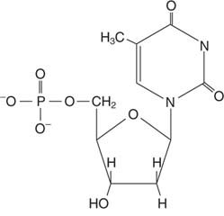
Fill in the chart. For examples, choose from the following structures:
- B. C. D.
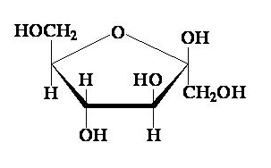
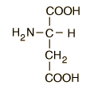
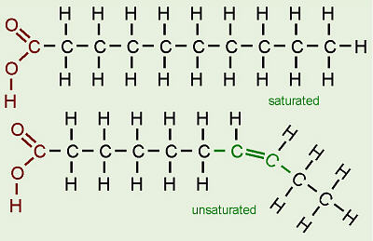

Macromolecule | Monomer | Elements | One Function | Example (Choose A, B, C or D)
Carbohydrate
Protein
Lipid
Nucleic Acid

Short Answer Questions

- Explain how polymers are related to monomers.

- Explain why proteins are considered polymers and lipids are not.

- Explain why nucleotides follow a base pairing rule when bonding to form a nucleic acid.

- Explain how dehydration synthesis and hydrolysis work.
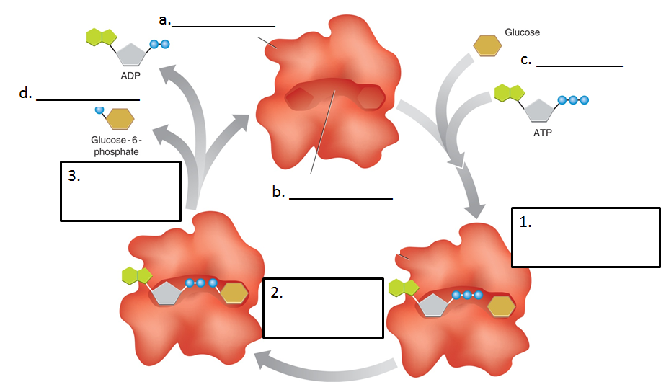
Fill in the chart regarding enzymes. The letters represent labels. In the boxes, explain what is occurring.

