Name: ____________________________________________
Grade & Element: ______________________________

DNA & RNA Quiz

- In a complete sentence, what are two functions of DNA?
____________________________________________________________________________________________________________________________________________________________________________________________________________________________________________________________________________________________________________

- What is the complimentary DNA strand that would be produced from the following DNA nucleotide sequence: 5’-ATCGAGATCA-3’

_________________________________________________________________

- What is the mRNA strand that would be produced from the following DNA nucleotide sequence: 5’-ATCGAGATCA-3’

________________________________________________________________

- What are the four DNA nucleotides? Circle the one that is not in RNA.

________________________________________________________

________________________________________________________

________________________________________________________

________________________________________________________

- What nucleotide is in RNA but not DNA?

________________________________________________________

- Laboratory analysis shows that a sample of DNA is 32% A. What is the percentage of C in the sample?

____________________________________

Multiple Choice-Write the letter of your answer on the line provided.

- __________ What is the process of forming an exact copy of the DNA molecule?
- Replication
- Transcription
- Translation
- Xeroxing

- __________ Which type of bond holds the nitrogen bases to one another across the middle of the helix?
- Covalent
- Ionic
- Metallic
- Hydrogen

- __________ Which enzyme separates the two strands of DNA to begin replication?
- Nuclease
- DNA polymerase
- Ligase
- Helicase

- __________ Which enzyme that adds free nucleotides to the DNA template during replication?
- Nuclease
- DNA polymerase
- Ligase
- Helicase

- __________ Which enzyme proofreads the copy of DNA looking for errors during replication?
- Nuclease
- DNA polymerase
- Ligase
- Helicase

- __________ Which of the following might cause accidental damage or changes in existing DNA?
- Exposure to chemicals
- Radioactivity
- Excessive exposure to ultraviolet light
- All of the above.

- __________ Where in the cell is an RNA copy made of DNA instructions?
- In the ER
- In the Golgi Complex
- In the nucleus
- In the ribosomes

- __________ What are the monomers of proteins?
- Nucleotides
- Simple sugars
- RNA
- Amino acids

- __________ Which type of RNA that carries the instructions for how to make a protein from the nucleus to the ribosomes?
- nRNA
- tRNA
- mRNA
- rRNA

True/False

- The process of DNA replication produces an identical copy of the original DNA double helix.

- The replication of DNA begins at one end of the DNA molecule and proceeds to the other end.

- At the end of replication, each DNA double helix has one original strand and one new strand.

- Damage to DNA can never be repaired.
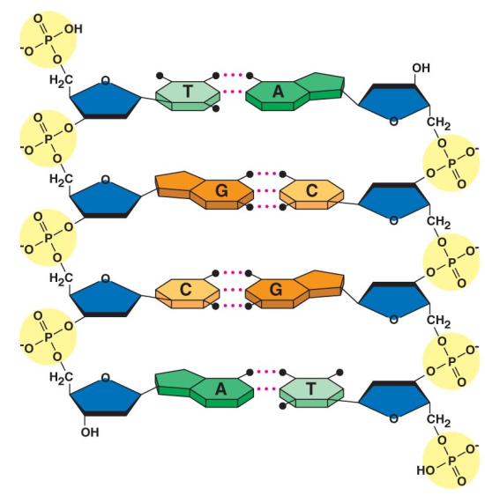
Label the parts of the nucleic acid polymer in the drawing.
Include all of these terms:
- Nucleotide (Circle an entire single nucleotide)
- Phosphate group
- Sugar
- Nitrogen base
- Hydrogen bond
- Covalent bond

- In a complete sentence, is the molecule pictured above DNA or RNA? How do you know (Give 2 reasons)?
____________________________________________________________________________________________________________________________________________________________________________________________________________________________________________________________________________________________________________

