Cell Cycle and Mitosis Worksheet
- What occurs during G2 phase?
- Cell growth and normal function
- Cell division
- DNA Replication
- Production of organelles for division

- Which phase will a cell enter if it enters a state of dormancy?
- S
- G2
- G1
- G0

- What occurs during G1 phase?
- Cell growth and normal function
- DNA Replication
- Production of organelles
- Cell division

- During which phase are the organelles for division replicated?
- G1
- G2
- S
- M

- A cell that divides infrequently will have a _____ G1 phase
- Short
- Long

- What occurs during S phase?
- DNA Replication
- Cell growth and normal function
- Cell division
- Production of organelles

- Which letter represents a chromatid?
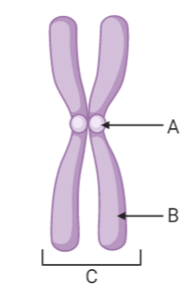
- A
- B
- C

- During which phase is the DNA replicated?
- G1
- G2
- S
- M

- Which of the following displays the phases of interphase in the correct order?
- G1, G2, M
- G1, S, G2
- G1, G2, S
- S, M, G1

- The sister chromatids are moving apart
- Interphase
- Prophase
- Metaphase
- Anaphase
- Telophase

- New nuclear membranes form around the chromosomes.
- Interphase
- Prophase
- Metaphase
- Anaphase
- Telophase
- Chromosomes line up in the middle of the cell.
- Interphase
- Prophase
- Metaphase
- Anaphase
- Telophase

- This phase is the reverse of prophase.
- Interphase
- Prophase
- Metaphase
- Anaphase
- Telophase

- The nuclear membrane disappears.
- Interphase
- Prophase
- Metaphase
- Anaphase
- Telophase

- Chromatin is found in the nucleus.
- Interphase
- Prophase
- Metaphase
- Anaphase
- Telophase

- In a duplicated chromosome, what is each half of the chromosome called?
- Chromatin
- Chromosome
- Halfosome
- Chromatid

- In which phase does the chromatin turn into condensed chromosomes?
- Prophase
- Telophase
- Anaphase
- Interphase

- In which phase of mitosis do the chromatids separate and move toward opposite sides of the cell?
- Prophase
- Telophase
- Metaphase
- Anaphase

- Which term describes the division of the cell NUCLEI?
- Cell Cycle
- Cytokinesis
- Mitosis
- Interphase
Use the following diagram to answer questions 20-24.
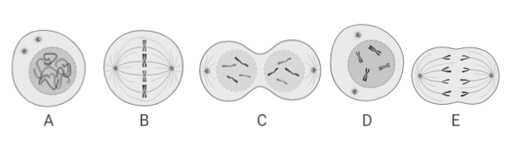
- Which cell is in the first phase of mitosis?
- A
- B
- C
- D
- E

- Which cell shows the longest phase of the cell cycle?
- A
- B
- C
- D
- E

- Which cell shows the separation of chromatids?
- A
- B
- C
- D
- E

- Which option shows the correct order of a cell progressing through the cell cycle?
- E -C - A - B - D
- A - D - B - E - C
- A - D - E - B - C
- A - B - C - D – E

- How many chromosomes are seen in Cell E?
- 2
- 4
- 6
- 8

- Which of the following is an accurate description of the difference between mitosis and cytokinesis?
- Mitosis is division of the cell, while cytokinesis is the cell's resting period.
- Mitosis occurs after cytokinesis in the cell cycle.
- Mitosis is division of the nucleus, while cytokinesis is division of the cytoplasm.
- Mitosis includes prophase and metaphase, while cytokinesis includes anaphase and telophase.

- What structure forms in plant cells during cytokinesis?
- Cell plate
- Cell furrow
- Metaphase plate
- Cell line

- Cytokinesis often happens during which phase of mitosis?
- Telophase
- Metaphase
- Interphase
- Prophase

- Nuclear membrane breaks down
- Interphase
- Prophase
- Metaphase
- Anaphase
- Telophase
- Cytokinesis

- Cell membrane is pinched via a contractile ring
- Interphase
- Prophase
- Metaphase
- Anaphase
- Telophase
- Cytokinesis

- 2 identical nuclei are formed
- Interphase
- Prophase
- Metaphase
- Anaphase
- Telophase
- Cytokinesis

- A cell plate is formed via vesicles
- Interphase
- Prophase
- Metaphase
- Anaphase
- Telophase
- Cytokinesis

- Cell duplicates its chromosomes
- Interphase
- Prophase
- Metaphase
- Anaphase
- Telophase
- Cytokinesis

- A metaphase plate is formed
- Interphase
- Prophase
- Metaphase
- Anaphase
- Telophase
- Cytokinesis

