Meiosis Worksheet
- A human zygote is....
- Haploid
- Diploid

- Which type of reproduction leads to an increased ability to respond to a changing environment?
- They both increase ability
- Sexual reproduction
- Neither have the ability
- Asexual reproduction

- How many chromosomes will a human zygote contain?
- 46
- Human zygotes do not contain chromosomes
- 23
- 92

- Which type of reproduction allows for offspring to be identical to the parents?
- Both allow for offspring to be identical
- Asexual reproduction
- Neither allow for offspring to be identical
- Sexual reproduction

- What do we call the two copies of chromosomes that are the same size and carry the same genes, one we received from our mom and one from our dad?
- Homologous
- Homogenous
- Homozygous
- Heterogenous

- What is the product of fertilization?
- Zygote
- New gametes
- Sperm
- Egg

- Which is true of sexual reproduction?
- It is typically faster than asexual reproduction
- It results in organisms that are more genetically different than asexual reproduction does
- It results in more offspring than asexual reproduction does
- It results in organisms that are less genetically different than asexual reproduction does

- Which of the following is true of independent assortment?
- It is when the chromosomes line up in an organized, specific manner in Metaphase I
- It is when the chromosomes swap genetic material in Metaphase I
- It is when the chromosomes separate from each other in Anaphase I
- It is when the chromosomes randomly line up at the metaphase plate in Metaphase I

- Which of the following is true of crossing over?
- It allows for a decrease in genetic diversity in daughter cells
- It occurs during interphase
- It allows for an increase in genetic diversity in daughter cells
- Full chromosomes will completely switch with other chromosomes

- Which of the following cells will NOT undergo meiosis?
- Human Sperm cells
- Human Egg cells
- Canine Liver cells
- Feline Brain cells

- When does crossing over occur?
- Interphase
- Metaphase I
- Anaphase I
- Prophase I

- At the end of meiosis I, we have:
- 2 genetically different diploid cells
- 2 genetically different haploid cells
- 2 genetically identical diploid cells
- 2 genetically identical haploid cells
- Which of the following is true of meiosis?
- There is no change in the number of chromosomes
- It results in a 1/2 reduction in the number of chromosomes
- It results in twice the number of chromosomes
- The daughter cells have two complete sets of chromosomes, in humans

- A diploid cell with 12 chromosomes undergoes meiosis. Which of the following will be the result?
- 4 haploid cells with 6 chromosomes
- 4 diploid cells with 6 chromosomes
- 4 haploid cells with 12 chromosomes
- 4 diploid cells with 12 chromosomes

- In stage of meiosis do chromatids separate to become chromosomes?
- Metaphase I
- Anaphase II
- Metaphase II
- Anaphase I

- Meiosis begins with ___________ and ends with __________
- 1 haploid cell ... 4 diploid cells
- 2 haploid cells ... 2 diploid cells
- 1 diploid cell ... 4 haploid cells
- 2 diploid cells ... 2 haploid cells

- Which phase of meiosis is shown in the image?
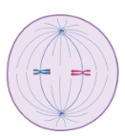
- Metaphase II
- Metaphase I
- Metaphase
- Anaphase II
- Which cells in the human body are made through the process of meiosis?
- Somatic cells
- X and Y chromosomes
- Gametes
- All body cells

- How do meiosis I and meiosis II differ?
- Meiosis I does not include crossing over, while meiosis II does
- Meiosis I is the separation of sister chromatids and meiosis II is the separation of homologous chromosomes
- Meiosis I is the separation of homologous chromosomes, and meiosis II is the separation of sister chromatids
- Meiosis I does not include independent assortment, while meiosis II does

- Homologous chromosomes are separated during
- Meiosis I
- Meiosis II
- Mitosis
- Fertilization

- Which of the following occurs in meiosis I, but not in meiosis II?
- Independent assortment
- Replication of DNA
- The formation of a spindle fiber
- Chromosomes lining up at the metaphase plate

- Independent assortment occurs during which stage of meiosis?
- Anaphase II
- Metaphase II
- Prophase I
- Telophase I
- Metaphase I

- In which stage(s) of meiosis do nuclear envelopes reform? choose all that apply
- Prophase II
- Telophase II
- Metaphase II
- Metaphase I
- Prophase I
- Telophase I
- Anaphase II
- Anaphase I

- Which of the following is a similarity between meiosis II and mitosis?
- The chromosome number is reduced by half.
- Sister chromatids are separated during anaphase
- The resulting daughter cells are all haploid
- Homologous chromosomes pair up during prophase

- Which phase of meiosis is shown in the image?
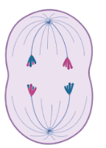
- Anaphase II
- Anaphase I
- Prophase II
- Prophase I

- When is DNA replicated for meiosis?
- DNA isn't replicated
- Interphase before Meiosis I
- Interphase before Meiosis II
- During Meiosis II

- Which phase of meiosis is shown in the image?
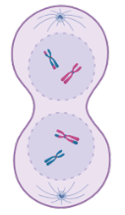
- Prophase I
- Prophase II
- Telophase II
- Telophase I

- In which stage of meiosis do homologous pairs of chromosomes separate?
- Metaphase I
- Metaphase II
- Anaphase I
- Anaphase II

- Which phase is shown in the image?
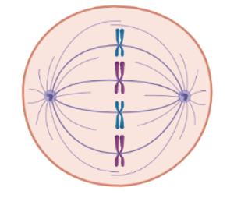
- Metaphase or Metaphase II
- Metaphase II
- Metaphase
- Metaphase I

- Meiosis _____ the parental chromosome number, while mitosis _______ it.
- Halves ... Maintains
- Halves ... Doubles
- Maintains ... Halves
- Doubles ... Maintains

- Which of the following is a similarity between meiosis and mitosis?
- Both increase genetic diversity in a population
- Both start with a haploid cell
- Both require 2 rounds of DNA replication
- Both start with a diploid cell

- If an organism needed to create new skin cells after suffering a wound, which processes would be necessary?
- Meiosis I
- Meiosis II
- Mitosis
- None of these processes would be necessary

- DNA is replicated BEFORE
- Meiosis I
- Meiosis II
- Mitosis
- Interphase

- Is meiosis I or meiosis II more similar to mitosis? Why?
- Meiosis II because DNA replication happens before it
- Meiosis II because it separates chromatids
- Meiosis I because it comes first
- Meiosis I because it separates homologous chromosomes

- Which phase is shown in the image?
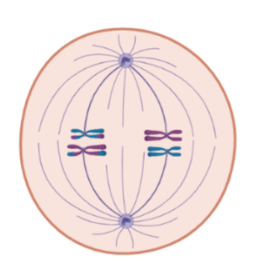
- Metaphase I
- Metaphase II
- Metaphase or Metaphase II
- Metaphase

- Which phase is shown in the image?
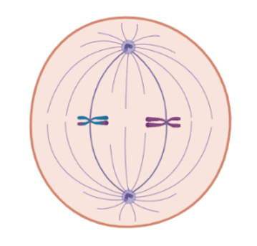
- Metaphase or Metaphase II
- Metaphase
- Metaphase II
- Metaphase I

- Homologous chromosomes are separated during
- Mitosis
- Interphase
- Meiosis II
- Meiosis I

- Chromatids are separated during
- Meiosis II
- Mitosis
- Meiosis I
- Interphase

- A __________ cell undergoes meiosis to produce _________.
- germline ... gametes
- germline ... somatic cells
- somatic ... somatic cells
- somatic ... gametes

- Which of the following is a correct statement regarding the relationship between mitosis and meiosis?
- Meiosis would be used to repair wounds in the reproductive system, while mitosis would be used to repair wounds everywhere else in the body
- Mitosis and meiosis are both utilized in creating new cells for the resulting zygote after fertilization
- Mitosis occurs in all cells, while meiosis only occurs in gametes
- Meiosis occurs before fertilization, and mitosis occurs after fertilization

- Which of the following are true times that interphase occurs?
- In between Meiosis I and Meiosis II
- Right before Meiosis I
- Right before Mitosis

- Which process creates the most genetic diversity in the resulting cells?
- All of these processes create equal genetic diversity
- None of these processes create genetic diversity
- Meiosis II
- Meiosis I
- Mitosis

- Does the cell have interphase before mitosis?

- Does the cell have interphase before meiosis?

- Summarize the overall purpose or goal of mitosis.

- Summarize the overall purpose or goal of meiosis.

- How many stages to mitosis are there? List/name each stage.

- How many stages to meiosis are there? List/name each stage.

- Does mitosis change the number of chromosomes per cell?

- Does meiosis change the number of chromosomes per cell?

- How many daughter cells does mitosis make?

- How many daughter cells does meiosis make?

- How similar are the daughter cells that mitosis makes?

- How similar are the daughter cells meiosis makes?

- If a human cell with a chromosome number of 46 undergoes mitosis, what number of chromosomes will be in each daughter cell?

- If a human cell with a chromosome number of 46 undergoes meiosis, what number of chromosomes will be in each daughter cell?

